

Visual approaches to cultural heritage

CERL Seminar at ETH Library, 14 March 2018
Venue: ETH Zurich, LEE Building (Leonhardstrasse 21), Room E 101.

The ‘icon turn’ has drawn the attention of scholars to visual material and its interpretation. This approach offers
a wide range of ways to integrate with text-based scholarship opening up new perspectives. Image-based search tools to sources and the visual presentation of research results have, however, not emerged equally fast. ETH Library, the Swiss centre for technical and natural scientific information, therefore takes the opportunity of organising the CERL Spring Seminar 2018 at ETH Library to discuss innovative forms of access and visualisation of research results.

Registration: please complete the registration form and send to secretariat@cerl.org before 6 March 2018.

08.30 | Registration and Coffee
 | Welcome and Opening Remarks
09.00-09.15 | Andreas Kirstein, Deputy Director, ETH Library  Kristian Jensen, Chairman, CERL
 | Introduction
09.15-09.30 | Stefan Wiederkehr, Head of Collections and Archives, ETH Library
 | Panel 1: Access to sources
09.30-10.15 | Meda Diana Hotea (ETH Library, Zurich): ETH Library’s visual and map-based access to selected digital information resources
10.15-11.00 | William O. Duba/Maria Widmer (University of Fribourg): e-codices and Fragmentarium. Building for and building upon the interoperability paradigm
11.00-11.30 | Coffee
11.30-12.15 | Claudia Fabian (Bayerische Staatsbibliothek, Munich): Image-based Similarity Search at Bayerische Staatsbibliothek
12.15-13.00 | Hans Brandhorst/Etienne Posthumus (Brill, Leiden): Arkyves – a serendipity engine
13.00-14.30 | Lunch
 | Panel 2: Visualisation of research results
14.30-15.15 | Matthias Bixler (University of Zurich): Connecting the Dots. The Use of Visualisations in Historical Network Research
15.15-16.00 | Matilde Malaspina (15cBOOKTRADE, Oxford): Image-search and text-search applied to  15th-century illustration
16.00-16.30 | Coffee
16.30-17.15 | Cristina Dondi (15cBOOKTRADE, Oxford and CERL): Tracking and visualizing the movement of books over time and space: Material Evidence in Incunabula (MEI) and 15cV
17.15-18.00 | To be confirmed.
19.30 | Dinner (for those who have registered their attendance)

Directions

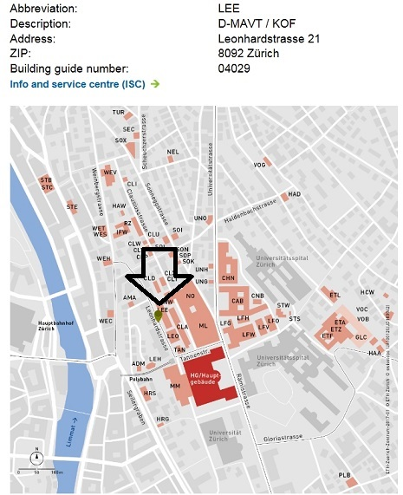

Travelling by public transport from Zurich Airport

By tram
- From the “Zurich Airport” tram stop
- Tram no. 10 (towards Bahnhofplatz/HB) as far as the “Haldenegg” stop. The tram runs every 7 to 15 minutes between 6 o’clock in the morning and 11 o’clock at night.
- Journey time: 30 minutes

By rail
- If you wish to travel from the airport to the city centre (Central Station), you are recommended to use the S-Bahn or mainline services. The trains depart from the “Zurich Airport” station.
- Journey time: approx. 10 minutes

You will require a ticket valid for 3 zones.
If you are spending the whole day in Zurich, it is worth buying a day pass (valid for 24 hours). A 24h ticket costs only twice as much as a regular one-way ticket.

Travelling by public transport from Zurich Central Station

From the “Bahnhofstrasse/HB” stop: Tram no. 6 (towards the Zoo) as far as the “ETH/Universitätsspital” stop. Journey time: approx. 6 minutes

From the “Bahnhofplatz/HB” stop: Tram no. 10 (towards the Airport or Oerlikon station) as far as the “Haldenegg” stop. Journey time: approx. 8 minutes
You will require a ticket that is valid for zone 110 (city of Zurich).

Further Information:
Campus: https://www.ethz.ch/en/campus/locations/zurich-region/HG.html
Tourist Information: https://www.zuerich.com/en

REGISTRATION FORM

ETH Library/CERL Seminar in Zürich

Visual approaches to cultural heritage

Wednesday 14 March

Please return the form to secretariat@cerl.org.

Name

Institution

Please indicate which of the following you will participate in.

Seminar: Visual approaches to cultural heritage

Dinner at your own expense at Restaurant Zeughauskeller,
Bahnhofstrasse 28 A, Beim Paradeplatz, CH-8001 Zürich
http://www.zeughauskeller.ch/en/home
Vegetarian €50, fish €55 and meat €60 (incl. drinks)

Payment instructions will be sent after reservations have been confirmed.

