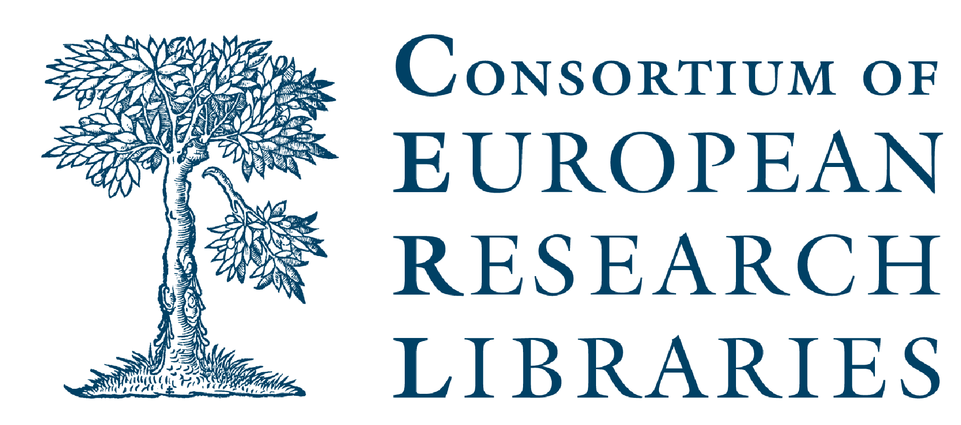

REGISTRATION FORM

ETH Library/CERL Seminar in Zürich

Visual approaches to cultural heritage

Wednesday 14 March

Please return the form to secretariat@cerl.org.

Name

Institution

Please indicate which of the following you will participate in.

Seminar: Visual approaches to cultural heritage

Dinner at your own expense at Restaurant Zeughauskeller,
Bahnhofstrasse 28 A, Beim Paradeplatz, CH-8001 Zürich
http://www.zeughauskeller.ch/en/home
Vegetarian €50, fish €55 and meat €60 (incl. drinks)

Payment instructions will be sent after reservations have been confirmed.

